Release Note (Qbuzz_release0.0.9_EAM11.7-Qbuzz- Damage_Changes_Release23Dec.zip)
EAM11.7-Qbuzz
Title:  EAM11.7-Qbuzz | Date Issued  23rd-Dec-2022

General comments
This implementation is based on INFOR EAM 11.7

List of observations addressed in this patch/fixes/modifications
S. No. | Description of Observation | Files
1. | EAM11.7- Qbuzz- Changes_Release 23 Dec | Db scripts  - SPC-306.sql  EF  - QBUZZ_external_SCHADE.txt

Pre-Installation instructions
In an effort to ensure that your INFOR EAM system continues to operate with maximum efficiency and minimal problems, Infor strongly recommends that you:
- Apply this fix to a test environment and perform your own user acceptance testing before applying this customization to your production environment.
- Db scripts can only be run when user defined screen has been generated.

Configuration Instructions
- Create User Defined Tab:- Administration Screen configuration User defined screen
Tab:- OUSUTR
Screen Name | OUCOST
Description | Additional Costs
Table Name | DMCOST
Parent Screen | SCHADE
Tab | Checked

Save the record.
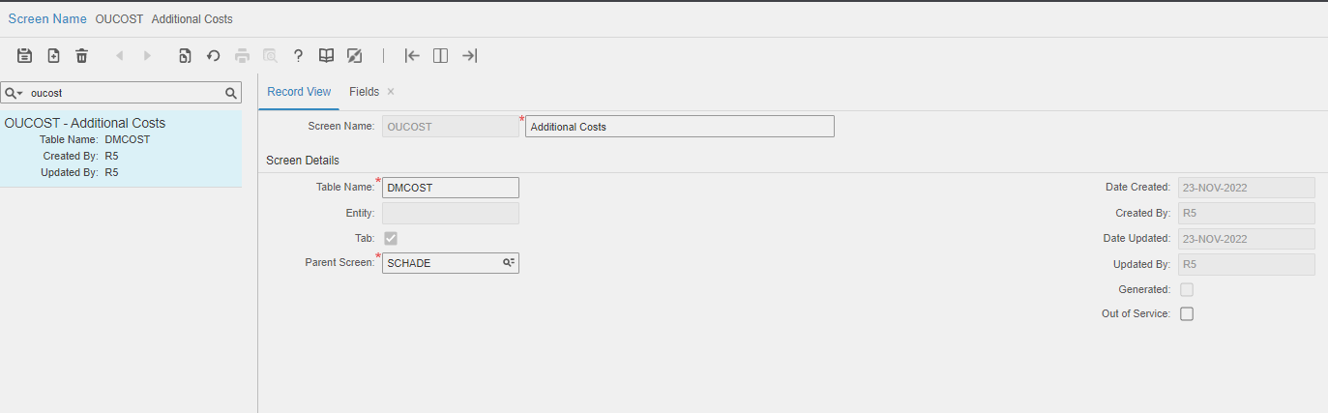

Navigation to fields

Please refer yellow lines in the attached files for fields.

- Extensible Framework:- Administrator Security Extensible Framework
Name: external_SCHADE
Screen: SCHADE

Contents List
The release is contained in compressed file, which contains the following files:
Db scripts
- SPC-306.sql

EF
- QBUZZ_external_SCHADE.txt

Release Note: Qbuzz_release0.0.9_EAM11.7-Qbuzz- Damage_Changes_Release23Dec.doc

